**G. H. RAISONI COLLEGE OF ENGINEERING & MANAGEMENT, WAGHOLI, PUNE**

**(An Autonomous Institute Affiliated to SPPU)**

**Department of Information Technology**

**TAE-2**

**Subject:** **MOBILE** **APPLICATION**

 **DEVELOPMENT**

**Mini Project Report On**

“Quiz Application”

**Academic Year 2023-24 Semester-VI**

**G. H. RAISONI COLLEGE OF ENGINEERING & MANAGEMENT, WAGHOLI, PUNE**

**(An Autonomous Institute Affiliated to SPPU)**

**Department of Information Technology Academic Year 2023-24 Semester-VI**

**Guided By:Mrs. Kiran Patil**

**Submitted by:**

**Apurva Narkhede - TYIT B-02**

**Mansi Rakhonde -TYIT B-15**

**Ram Sable -TYITB-16**

**Shital Thigale -TYIT A-44**



**CERTIFICATE**

This is to certify that **“**TO DO LIST APP**”** embodies the original work done by **“Apurva Nakhede , Mansi Rakhonde , Ram Sable , Shital Thigale ”** this project submission as a partial fulfilment of the requirement for the MiniProject in subject UITL304A | Elective - I Mobile Application Development of TY B.

Tech. Degree, IV Semester, of Pune University during the academic year 2023-2024.

**Date: 19-05-2022Place:** Pune

**ACKNOWLEDGEMENT**

We would like to express our sincere thanks to Mrs. Kiran Patil under whose valuable guidance and light of knowledge, we could complete this project.

We take this opportunity to thank all the staff members of Department Of Information Technology Engineering for their help whenever required. Finally we express sincere thanks to all those who have helped us directly or indirectly in many ways in completion of this project work and I would like to extend my Deep appreciation to all my group members, without their support and Coordination we would not have been able to complete this Project.

|  |  |  |
| --- | --- | --- |
| **Sr.No** | **TITLE** | **Page No** |
| **1.** | **Abstract** | **6** |
| **2.** | **Introduction** | **7** |
| **3.** | **Problem Statement** | **8** |
| **4.** | **Project Features** | **9** |
| **5.** | **System Architecture** | **10** |
| **6.** | **Development Process** | **11** |
| **7.** | **App Screenshots** | **17** |
| **8.** | **Results and Evaluation** | **18** |
| **9.** | **Conclusion** | **19** |
| **10.** | **References** | **20** |

## ABSTRACT

The Quiz Application is a mobile app developed using Java in Android Studio, aimed at helping users organize their tasks efficiently. This report outlines the development process, features, system architecture, and evaluation of the application. The app provides a user-friendly interface for adding, editing, and prioritizing tasks, enhancing productivity and task management.

## INTRODUCTION

Development of Android-based Quiz application is mainly required by students and learners to prepare themselves for different examinations directly through Smart-Phones and tablets in hands. The main aim of this project is to facilitate students in learning, gaining and improving their knowledge skills. At the meantime, our app provides them fun so that the users can prepare for interviews, entrance tests or any other corresponding purposes in a fresh mood and can’t get bored or frustrated due to the dullness of application. We designed the application to facilitate the users to be able to take short quizzes using portable devices such as smart phones and tablets.

However, the most attractive feature of our app is that we take learning and fun side by side. Our app provides them the facility to revise their knowledge or to learn something advantageous at one place without wasting their time.

## PROBLEM STATEMENT

It is essentially required to assist students for the learning and preparation of different tests conducted for admission in higher studies in Pakistan. However, there exist no such application in

android-based platform, which can provide candidates with both preparation of such tests in user friendly and interactive way. This is what we tried to address in the development of Quizzy: Quiz Application Development using Android-Based Platform.

## PROJECT FEATURES

* Task creation: Users can easily create new tasks with titles, descriptions, due dates, and priority levels.
* Task management: The app allows users to organize tasks into categories or projects for better management.
* Priority levels: Tasks can be assigned priority levels such as high, medium, or low to indicate their importance.
* Reminders: Users receive notifications or reminders for upcoming task deadlines or events.
* Task completion: Tasks can be marked as completed, and completed tasks can be archived or deleted.
* Customization: Users can customize the app's theme, layout, and notification settings according to their preferences.

Synchronization: The app synchronizes tasks across multiple devices to ensure seamless access and updates.

## SYSTEM ARCHITECTURE

Computer General Knowledge Quiz section is a repository of Multiple Choice Question that makes you aware about evolving nature of the competitive examination; this quiz is about subjects related to the computer field. It’s a general computer quiz. This quiz is useful for the preparation of any computer field test. In this quiz app, questions are given along with four choices, and at the end, the correct choice is also given. After preparation, students can check their level of preparation through the quiz

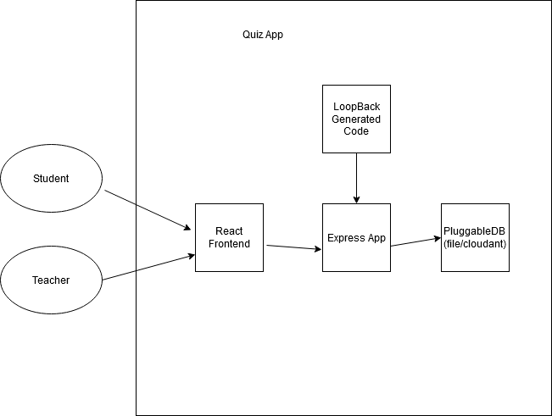

**JAVA CODE:**

public class Question

{

private int answerResId;

private boolean answerTrue;

public Question(int answerResId, boolean answerTrue)

{

this.answerResId = answerResId;

this.answerTrue = answerTrue;

}

public int getAnswerResId()

{

return answerResId;

}

public void setAnswerResId(int answerResId)

{

this.answerResId = answerResId;

}

public boolean isAnswerTrue()

{

return answerTrue;

}

public void setAnswerTrue(boolean answerTrue)

{

this.answerTrue = answerTrue;

}

}

**XML CODE:**

**import** android.annotation.SuppressLint;

**import** android.os.Build;

**import** android.os.Bundle;

**import** android.util.Log;

**import** android.view.View;

**import** android.widget.Button;

**import** android.widget.ImageButton;

**import** android.widget.ImageView;

**import** android.widget.TextView;

**import** android.widget.Toast;

**import** androidx.annotation.RequiresApi;

**import** androidx.appcompat.app.AppCompatActivity;

**public** **class** MainActivity **extends** AppCompatActivity

**implements** View.OnClickListener {

**private** Button falseButton;

**private** Button trueButton;

**private** ImageButton nextButton;

**private** ImageButton prevButton;

**private** ImageView Image;

**private** TextView questionTextView;

**private** **int** correct = 0;

**private** **int** currentQuestionIndex = 0;

**private** Question[] questionBank = **new** Question[] {

**new** Question(R.string.a, **true**),

**new** Question(R.string.b, **false**),

**new** Question(R.string.c, **true**),

**new** Question(R.string.d, **true**),

**new** Question(R.string.e, **true**),

**new** Question(R.string.f, **false**),

    };

    @Override

**protected** **void** onCreate(Bundle savedInstanceState)

    {

**super**.onCreate(savedInstanceState);

        setContentView(R.layout.activity_main);

        falseButton = findViewById(R.id.false_button);

        trueButton = findViewById(R.id.true_button);

        nextButton = findViewById(R.id.next_button);

        prevButton = findViewById(R.id.prev_button);

        questionTextView

            = findViewById(R.id.answer_text_view);

        Image = findViewById(R.id.myimage);

        falseButton.setOnClickListener(**this**);

        trueButton.setOnClickListener(**this**);

        nextButton.setOnClickListener(**this**);

        prevButton.setOnClickListener(**this**);

    }

    @SuppressLint("SetTextI18n")

    @RequiresApi(api = Build.VERSION_CODES.LOLLIPOP)

    @Override

**public** **void** onClick(View v)

    {

**switch** (v.getId()) {

**case** R.id.false_button:

            checkAnswer(**false**);

**break**;

**case** R.id.true_button:

            checkAnswer(**true**);

**break**;

**case** R.id.next_button:

**if** (currentQuestionIndex < 7) {

                currentQuestionIndex

                    = currentQuestionIndex + 1;

**if** (currentQuestionIndex == 6) {

                    questionTextView.setText(getString(

                        R.string.correct, correct));

                    nextButton.setVisibility(

                        View.INVISIBLE);

                    prevButton.setVisibility(

                        View.INVISIBLE);

                    trueButton.setVisibility(

                        View.INVISIBLE);

                    falseButton.setVisibility(

                        View.INVISIBLE);

**if** (correct > 3)

                        questionTextView.setText(

                            "CORRECTNESS IS " + correct

                            + " "

                            + "OUT OF 6");

**else**

                        Image.setImageResource(

                            R.drawable.resu);

                }

**else** {

                    updateQuestion();

                }

            }

**break**;

**case** R.id.prev_button:

**if** (currentQuestionIndex > 0) {

                currentQuestionIndex

                    = (currentQuestionIndex - 1)

                      % questionBank.length;

                updateQuestion();

            }

        }

    }

    @RequiresApi(api = Build.VERSION_CODES.LOLLIPOP)

**private** **void** updateQuestion()

    {

        Log.d("Current",

              "onClick: " + currentQuestionIndex);

        questionTextView.setText(

            questionBank[currentQuestionIndex]

                .getAnswerResId());

**switch** (currentQuestionIndex) {

**case** 1:

            Image.setImageResource(R.drawable.f2);

**break**;

**case** 2:

            Image.setImageResource(R.drawable.f3);

**break**;

**case** 3:

            Image.setImageResource(R.drawable.f4);

**break**;

**case** 4:

            Image.setImageResource(R.drawable.f5);

**break**;

**case** 5:

            Image.setImageResource(R.drawable.f6);

**break**;

**case** 6:

            Image.setImageResource(R.drawable.f7);

**break**;

**case** 7:

            Image.setImageResource(R.drawable.f1);

**break**;

        }

    }

**private** **void** checkAnswer(**boolean** userChooseCorrect)

    {

**boolean** answerIsTrue

            = questionBank[currentQuestionIndex]

                  .isAnswerTrue();

**int** toastMessageId;

**if** (userChooseCorrect == answerIsTrue) {

            toastMessageId = R.string.correct_answer;

            correct++;

        }

**else** {

            toastMessageId = R.string.wrong_answer;

        }

        Toast

            .makeText(MainActivity.**this**, toastMessageId,

                      Toast.LENGTH_SHORT)

            .show();

    }

}

**Activity_main.xml :**

<?**xml** version="1.0" encoding="utf-8"?>

<!--Using linear layout with vertical orientation and center gravity

<**LinearLayout** xmlns:android="<http://schemas.android.com/apk/res/android>"

    xmlns:app="<http://schemas.android.com/apk/res-auto>"

    xmlns:tools="<http://schemas.android.com/tools>"

    android:layout_width="match_parent"

    android:background="#FFFFFF"

    android:layout_height="match_parent"

    android:orientation="vertical"

    android:gravity="center"

    tools:context=".MainActivity">

    <!--ImageView used for showing pictures along with questions-->

    <**ImageView**

        android:id="@+id/myimage"

        android:layout_width="wrap_content"

        android:src="@drawable/f1"

        android:layout_height="wrap_content"/>

    <!--TextView used for showing questions on screen-->

    <**TextView**

        android:id="@+id/answer_text_view"

        android:text="@string/a"

        android:textColor="@android:color/black"

        android:textSize="30sp"

        android:padding="10dp"

        android:layout_width="wrap_content"

        android:layout_height="wrap_content"/>

    <!--Using another LinearLayout for showing buttons

        in horizontal orientation-->

    <**LinearLayout**

        android:layout_width="wrap_content"

        android:layout_height="wrap_content">

        <!--TrueButton-->

        <**Button**

            android:id="@+id/true_button"

            android:layout_marginRight="20dp"

            android:backgroundTint="#5BD91B"

            android:layout_width="wrap_content"

            android:layout_height="wrap_content"

            android:textSize="20sp"

            android:text="@string/true_text" />

        <!--FalseButton-->

        <**Button**

            android:id="@+id/false_button"

            android:layout_marginLeft="20dp"

            android:layout_width="wrap_content"

            android:backgroundTint="#E33328"

            android:layout_height="wrap_content"

            android:textSize="20sp"

            android:text="@string/false_text" />

    </**LinearLayout**>

    <**LinearLayout**

        android:layout_width="wrap_content"

        android:layout_height="wrap_content">

        <!--PreviousButton-->

        <**ImageButton**

            android:id="@+id/prev_button"

            android:layout_width="wrap_content"

            android:layout_height="wrap_content"

            android:src="@drawable/baseline_keyboard_arrow_left_black_18dp"

            android:backgroundTint="#DFD2D1"

            android:text="@string/prev_text" />

        <!--NextButton-->

        <**ImageButton**

            android:id="@+id/next_button"

            android:layout_width="wrap_content"

            android:layout_height="wrap_content"

            android:backgroundTint="#DFD2D1"

            android:src="@drawable/baseline_keyboard_arrow_right_black_18dp"

            android:text="@string/next_text" />

    </**LinearLayout**>

</**LinearLayout**>

**APPLICATION SCREENSHOT**

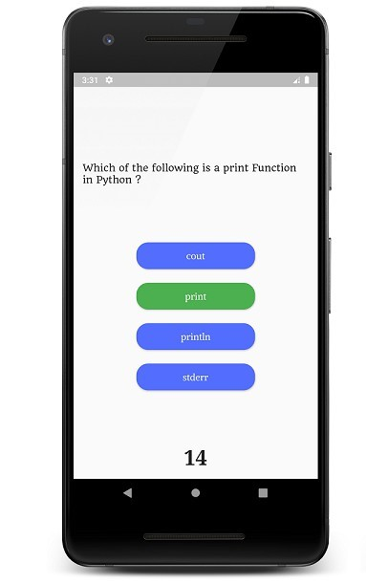

## RESULTS AND EVALUATION

The Quiz Application was evaluated based on criteria such as user experience, performance, reliability, and functionality. User feedback surveys and usability testing were conducted to gather insights into the application's strengths and areas for improvement. The application received positive feedback for its intuitive interface, task management features, and synchronization capabilities. However, some users reported minor bugs or suggestions for additional features, which were addressed in subsequent updates.

## CONCLUSION

The main purpose of our project is to develop an application that offers new aspect of learning and improving knowledge in educational area. Most of the available apps are entertainment-based, which mostly do not contribute to the academic enhancement of the students.

The theme of our quiz is to provide user to practice for aubjective tests conducted on national level,so in this app we in Computer science field.This quiz is useful for the preparation of any of the computer-related test.

# REFERENCES

<http://quizhub.com/quiz/quizhub.cfm>

<http://www.jagranjosh.com/articles/computer-general>

<http://www.eduzip.com/category/computer-science>